1) Oscilloscope image showing the voltage across the current measuring resistor with motor running.
2) Oscilloscope image showing that the scope channel has been set to measure current, with the correct calibration.
3) Oscilloscope image showing only one or two of the current pulses.
4) Oscilloscope image showing both the raw and low pass filtered measurements of motor current with varying load.
5) Image showing your calculation of the motor efficiency from mechanical power output and electrical power input.
1)
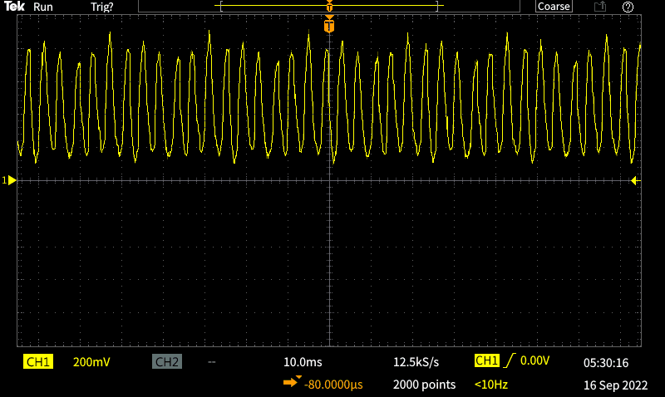

2)
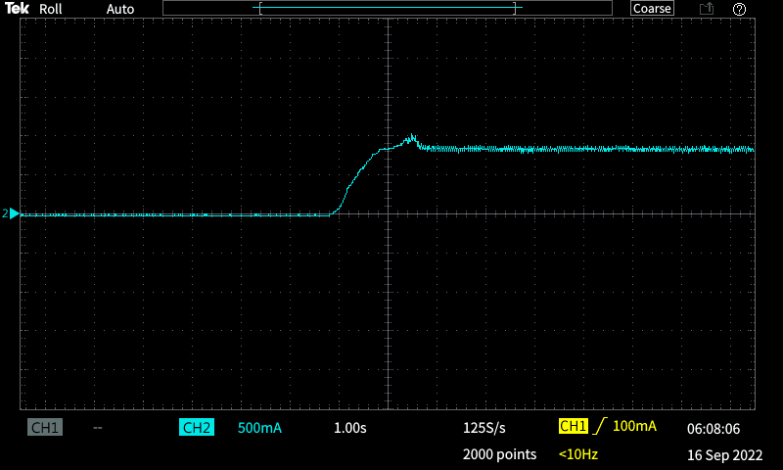
3)
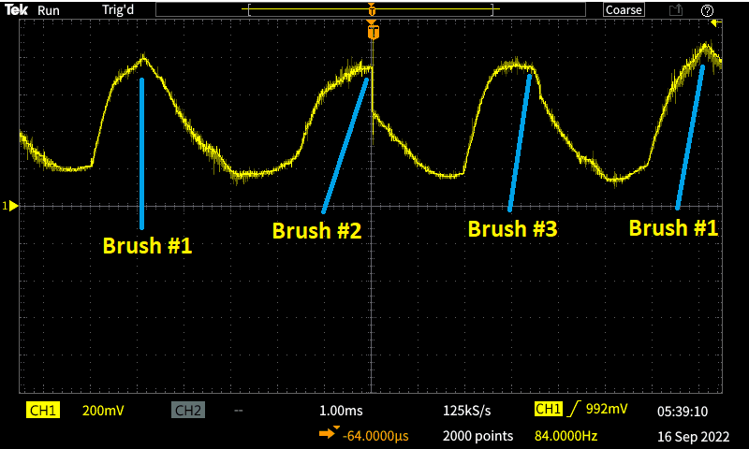
Figure 1 only shows the voltage across the resistor instead of the current. I forgot/misunderstood the question.
4)
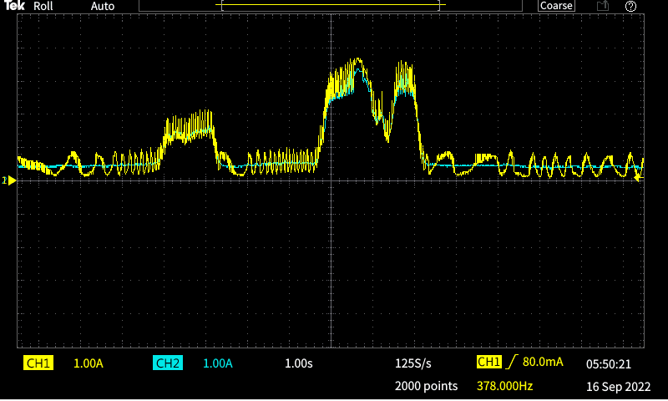

 | 500g | 250g
Current | 150mA | 90mA
Time | 9.8s | 7.52s
ω | 2.040816 | 2.659574
Torque | 0.24525N*m | 0.122625N*m
Power | 0.50051 W | 0.32613 W
P_{e} | 1.5 W | 0.9 W
η | 0.333673 W | 0.362367 W
k | 1.635 | 1.3625

